Devansh Shah  
1914078  
  
From the Data pane, drag Order Date to the Columns shelf.

From the Data pane, drag Sales to the Rows shelf.s

From the Data pane, drag Category to the Columns shelf and place it to the right of

YEAR(Order Date).

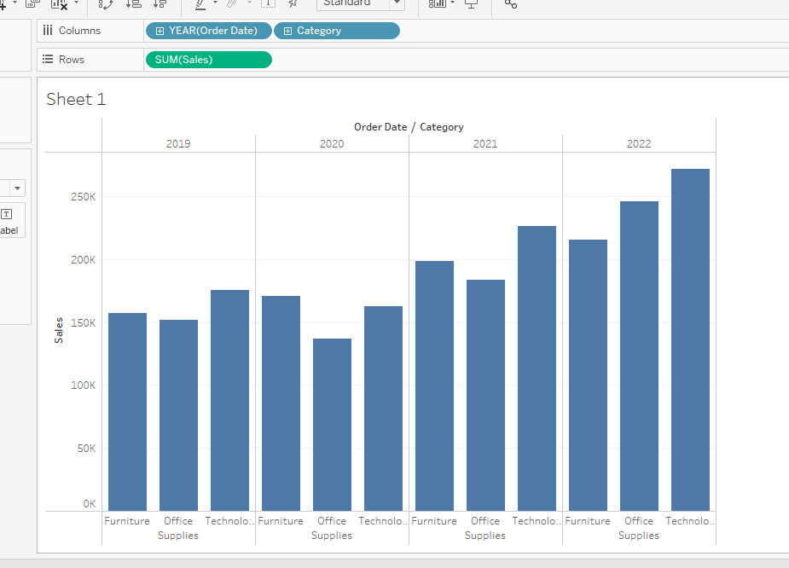

drag Sub-Category to the Columns shelf.

